

**SAVEETHA SCHOOL OF ENGINEERING**

**SAVEETHA INSTITUTE OF MEDICAL AND TECHNICAL SCIENCES**

**CHENNAI-602105**

**ONLINE HOTEL ROOM BOOKING**

**A CAPSTONE PROJECT REPORT**

*Submitted in the partial fulfillment for the completion of the course*

**CSA4311- INTERNET PROGRAMMING FOR DHTML**

**IN**

**COMPUTER SCIENCE AND ENGINEERING**

**Submitted by**

**Roshni Prabakar (192211823)**

**Rohitha.G (192210242)**

**Under the Supervision of**

**Dr.S.Senthilvadivu**

**NOVEMBER 2024**

**DECLARATION**

We, **Roshni Prabakar (192211823), Rohitha.G (192210242)** students of **Bachelor of Engineering in the Department** of Computer Science and Engineering, Saveetha Institute of Medical and Technical Sciences, Saveetha School of Engineering, Chennai, hereby declare that the work presented in this Capstone Project Work entitled **Online Hotel Room Booking** is the outcome of our own bonafide work and is correct to the best of our knowledge and this work has been undertaken taking care of Engineering Ethics.

Roshni Prabakar (1921121073)

Rohitha.G (192210242)

Date:

Place:

**CERTIFICATE**

This is to certify that the project entitled **“Online Hotel Room Booking”** submitted by **Roshni Prabakar and Rohitha.G** has been carried out under my supervision. The project has been submitted as per the requirements in the current semester of B.E. Computer Science and Engineering.

Supervisor

Dr.S.Senthilvadivu

**Table of Contents**

|  |  |  |
| --- | --- | --- |
| **S.NO** | **TOPICS** | **PAGE NO.** |
| 1 | **Abstract** |  |
| 2 | **Introduction** |  |
| 3 | **Project Description**  About your project |  |
| 4 | **Problem Description** |  |
| 5 | **Tool Description** |  |
| 6 | **Operations** |  |
| 7 | **Approach / Module Description / Functionalities** |  |
| 8 | **Implementation**  Coding |  |
| 9 | **Result**  Output with Screenshots |  |
| 10 | **Conclusion**  **References** |  |

**ABSTRACT**

The Online Hotel Room Booking project aims to provide a comprehensive solution for managing hotel operations efficiently and improving visitor experiences. This system includes user registration, login capability, and information about the hotel and its branches, making it an effective tool for hotel management.

The project is built with HTML, CSS, JavaScript for the frontend, PHP for server-side scripting, and MySQL for database management.To assist setup and use, XAMPP software is used to demonstrate database connectivity.This project relies heavily on XAMPP, an open-source cross-platform web server solution stack package, which provides a local development environment for PHP and MySQL. XAMPP comprises the Apache HTTP Server, MariaDB (a MySQL clone), and PHP and Perl interpreters. This makes it an excellent solution for developers who need to set up a local server environment fast and efficiently.

**INTRODUCTION**

The hospitality business requires reliable systems to efficiently manage operations, bookings, and client data. Manual administration of hotel operations can result in a variety of issues, including errors, inefficiencies, and poor visitor experiences. For example, human data entry might lead to multiple bookings, erroneous reservation details, and delayed responses to guest inquiries. Furthermore, managing consumer data without automation is time-consuming and vulnerable to security breaches. The Hotel Management System project tackles these essential concerns by providing a comprehensive, automated, web-based solution for streamlining hotel operations guaranteeing that activities are seamless and efficient. Guests may instantly book, check room availability, and manage their reservations, all of which contribute to a smooth user experience. Furthermore, the system improves data quality and security, guaranteeing that client information is handled carefully and preserved securely.

This project provides a user-friendly interface that allows guests to easily register, log in, and access detailed information about the hotel and its services. By automating these processes, the system significantly reduces the potential for human error and ensures that operations run smoothly and efficiently. Guests can quickly make bookings, check room availability, and manage their reservations, all of which contribute to a seamless user experience. Moreover, the system enhances data accuracy and security, ensuring that customer information is handled with care and stored securely.In addition to improving operational efficiency, the Online Hotel Room Booking the overall guest experience. Guests benefit from a faster, more reliable booking process, and staff can focus on providing exceptional service rather than dealing with administrative tasks. The system’s intuitive design ensures that both guests and hotel staff can navigate and use the platform with ease. The web-based nature of the solution also means that it is accessible from anywhere, at any time, providing convenience for both guests planning their stay and hotel managers overseeing operations.

In summary, the Online Hotel Room Booking project leverages modern technology to provide a robust solution for the hospitality industry. By automating the management of operations, bookings, and customer data, the system not only improves efficiency but also enhances the overall guest experience. This automated, web-based approach addresses the inherent challenges of manual management, offering a reliable, secure, and user-friendly platform that meets the needs of both hotel staff and guests.

**Project Description**

**The Online Hotel Room Booking project consists of several key components:**

* Home Page: Provides an overview of the hotel and its branches.
* Registration Page: Allows new users to register by entering their personal details.
* Login Page: Facilitates user authentication.
* About Us Page: Displays contact information and details about the hotel.

These components are implemented using web technologies such as HTML, CSS, JavaScriptwith data stored. The project ensures data integrity, security, and ease of access.

**Problem Description**

**Manual Online hotel Room Booking several challenges:**

* Inefficiency: Handling bookings and guest information manually is time-consuming.
* Errors: Manual data entry can lead to errors such as double bookings or incorrect information.
* Lack of Real-Time Updates: Manual systems do not provide real-time updates, leading to potential overbookings.
* Poor Guest Experience: Inefficient management can result in delayed responses and poor guest satisfaction.

The Online Hotel Room Booking aims to solve these problems by automating the booking process and providing a streamlined management solution.

**Tool Description**

**The project utilizes various tools and technologies:**

* HTML (HyperText Markup Language): Used for creating the structure of web pages.
* CSS (Cascading Style Sheets): Used for styling and layout of web pages.
* JavaScript: Used for client-side validation and enhancing interactivity.

**Operation**

**The system operates through a series of interconnected web pages and server-side scripts:**

1. Home Page: Displays an overview of the hotel and its branches.
2. Registration Page: New users can register by filling out a form with their personal details.
3. Login Page: Registered users can log in by entering their username and password.
4. About Us Page: Provides contact information and details about the hotel.

**Module Description**

* User Registration:
  + Frontend: The registration form collects user details such as name, phone number, username, password, gender, room preference, and number of persons.
  + Client-Side Validation: JavaScript is used to validate form inputs before submission.

User Login:

* + Frontend: The login form collects the username and password.
  + Server-Side Authentication: PHP checks the entered credentials against the stored data in the database.
* Information Display:
  + Home Page: Displays a welcoming message and information about the hotel.
  + About Us Page: Lists contact information and details about the hotel and its branches.

**IMPLEMNTATION**

**Client-side Code:**

<!DOCTYPE html>

<html lang="en">

<head>

<meta charset="UTF-8">

<title>Online Hotel Management System</title>

<style>

/* Basic styles for layout */

body {

font-family: Arial, sans-serif;

margin: 0;

padding: 0;

background-image: url('hotel.jpg');

background-size: cover;

background: linear-gradient(to right, #e2e2e2, #ffffff);

color: #333;

}

nav {

background: #007bff;

padding: 15px;

box-shadow: 0 4px 10px rgba(0, 0, 0, 0.2);

position: fixed;

width: 100%;

top: 0;

z-index: 1000;

transition: background 0.3s, transform 0.3s;

}

nav:hover {

background: #0056b3;

transform: translateY(-5px);

}

nav ul {

list-style: none;

margin: 0;

padding: 0;

display: flex;

justify-content: space-around;

align-items: center;

}

nav ul li {

margin: 0;

}

nav ul li a {

color: #ffffff;

text-decoration: none;

padding: 10px 20px;

border-radius: 5px;

transition: background-color 0.3s, transform 0.3s;

}

nav ul li a:hover {

background-color: #0056b3;

transform: scale(1.1);

}

#content {

padding: 80px 20px 20px; /* Adjusted for fixed nav */

min-height: 400px;

background: #ffffff;

box-shadow: 0 4px 10px rgba(0, 0, 0, 0.1);

border-radius: 8px;

margin: 20px auto;

max-width: 1200px;

transition: opacity 1s ease-in-out, transform 1s ease-in-out;

}

#content.fade-in {

opacity: 1;

transform: translateY(0);

}

#content.hidden {

opacity: 0;

transform: translateY(20px);

}

h2 {

margin-bottom: 20px;

color: #007bff;

text-shadow: 1px 1px 2px rgba(0, 0, 0, 0.1);

font-size: 2em;

}

form input, form select, form textarea {

display: block;

margin-bottom: 10px;

padding: 10px;

width: 100%;

max-width: 400px;

border: 1px solid #ced4da;

border-radius: 5px;

transition: border-color 0.3s, box-shadow 0.3s;

}

form input:focus, form select:focus, form textarea:focus {

border-color: #007bff;

box-shadow: 0 0 5px rgba(0, 123, 255, 0.5);

outline: none;

}

form input[type="submit"] {

background-color: #007bff;

color: white;

border: none;

cursor: pointer;

padding: 12px 20px;

border-radius: 5px;

transition: background-color 0.3s, transform 0.3s;

}

form input[type="submit"]:hover {

background-color: #0056b3;

transform: scale(1.05);

}

form label {

margin-top: 10px;

display: block;

font-weight: bold;

}

#logout {

margin-left: auto;

color: #ffffff;

cursor: pointer;

transition: color 0.3s;

}

#logout:hover {

color: #ff7f7f;

}

/* Admin section styles */

.admin-section {

background-color: #f8f9fa;

padding: 15px;

margin-bottom: 20px;

border: 1px solid #dee2e6;

border-radius: 8px;

box-shadow: 0 4px 10px rgba(0, 0, 0, 0.1);

transition: background-color 0.3s, transform 0.3s;

}

.admin-section:hover {

background-color: #e9ecef;

transform: scale(1.02);

}

/* Table styles */

table {

width: 100%;

max-width: 100%;

border-collapse: collapse;

margin-bottom: 20px;

background: #ffffff;

border-radius: 8px;

overflow: hidden;

box-shadow: 0 4px 10px rgba(0, 0, 0, 0.1);

}

table, th, td {

border: 1px solid #dee2e6;

}

th, td {

padding: 15px;

text-align: left;

transition: background-color 0.3s;

}

th {

background-color: #007bff;

color: #ffffff;

}

tr:nth-child(even) {

background-color: #f2f2f2;

}

tr:hover {

background-color: #e9ecef;

transition: background-color 0.3s;

}

/* Footer */

footer {

background-color: #007bff;

color: #ffffff;

text-align: center;

padding: 20px 0;

position: relative;

bottom: 0;

width: 100%;

box-shadow: 0 -4px 10px rgba(0, 0, 0, 0.2);

transition: background-color 0.3s, transform 0.3s;

}

footer:hover {

background-color: #0056b3;

transform: translateY(-5px);

}

/* Hide elements */

.hidden {

display: none;

}

/* Animations */

@keyframes fadeIn {

from {

opacity: 0;

transform: translateY(20px);

}

to {

opacity: 1;

transform: translateY(0);

}

}

.fade-in {

animation: fadeIn 1s ease-in-out;

}

</style>

</head>

<body>

<!-- Navigation Bar -->

<nav>

<ul id="navMenu">

<li><a href="#" onclick="loadPage('home')">Home</a></li>

<li><a href="#" onclick="loadPage('about')">About Us</a></li>

<li><a href="#" onclick="loadPage('rooms')">Rooms</a></li>

<li><a href="#" onclick="loadPage('booking')">Booking</a></li>

<li><a href="#" onclick="loadPage('contact')">Contact Us</a></li>

<li id="adminLink" class="hidden"><a href="#" onclick="loadPage('admin')">Admin Panel</a></li>

<li id="userLink"><a href="#" onclick="loadPage('login')">Login/Register</a></li>

<li id="logout" class="hidden" onclick="logout()">Logout</li>

</ul>

</nav>

<!-- Content Section -->

<div id="content">

<!-- Default content will be loaded here -->

</div>

<!-- Footer -->

<footer>

<p>&copy; SPARK Hotel Management System. All rights reserved.</p>

</footer>

<script>

let users = []; // Array to store user profiles

let bookings = []; // Array to store bookings

let currentUser = null;

let isAdmin = false;

function loadPage(page) {

var content = document.getElementById('content');

if ((page === 'booking' || page === 'profile' || page === 'history') && !currentUser) {

alert('Please login or register first.');

loadPage('login');

return;

}

if (page === 'admin' && !isAdmin) {

alert('Admin access only.');

loadPage('login');

return;

}

if (page === 'home') {

content.innerHTML = `

<h2>Home</h2>

<p>Welcome to our luxurious hotel. Enjoy a world-class stay with top-tier services.Step into a World of elegance and sophistication at Spark Hotel,where we blend timeless luxury with modern ameneties to offer you an unforgettable stay.Whether you are here for business or leisure ,our hotel promises an experience defined by impeccable service,stunning accomodations,and first class amenities. </p>`;

} else if (page === 'about') {

content.innerHTML = `

<h2>About Us</h2>

<p>We are a premier hotel located in the heart of the city, offering comfort, luxury, and exceptional services to our guests.</p>`;

} else if (page === 'rooms') {

content.innerHTML = `

<h2>Room Types</h2>

<p>Introduction to our room types:</p>

<ul>

<li>Standard Room</li>

<li>Deluxe Room</li>

<li>Executive Suite</li>

<li>Presidential Suite</li>

</ul>`;

} else if (page === 'booking') {

content.innerHTML = `

<h2>Room Booking</h2>

<form onsubmit="bookRoom(event)">

<label for="roomType">Room Type:</label>

<select id="roomType" required>

<option value="Standard">Standard</option>

<option value="Deluxe">Deluxe</option>

<option value="Executive">Executive Suite</option>

<option value="Presidential">Presidential Suite</option>

</select>

<label for="checkin">Check-In Date:</label>

<input type="date" id="checkin" required>

<label for="checkout">Check-Out Date:</label>

<input type="date" id="checkout" required>

<input type="submit" value="Book Now">

</form>

<button onclick="loadPage('history')">View Booking History</button>`;

} else if (page === 'history') {

showBookingHistory();

} else if (page === 'contact') {

content.innerHTML = `

<h2>Contact Us</h2>

<p>For inquiries, please contact us at:</p>

<p>Email: sparkmanagement@hotel.com</p>

<p>Phone: +1 234 567 8900</p>`;

} else if (page === 'login') {

content.innerHTML = `

<h2>Login or Register</h2>

<button onclick="showLogin()">Login</button>

<button onclick="showRegister()">Register</button>

<div id="authSection"></div>`;

} else if (page === 'profile') {

content.innerHTML = `

<h2>Your Profile</h2>

<p>Name: ${currentUser.name}</p>

<p>Email: ${currentUser.email}</p>

<button onclick="editProfile()">Edit Profile</button>`;

} else if (page === 'admin') {

showAdminPanel();

}

}

function showLogin() {

var authSection = document.getElementById('authSection');

authSection.innerHTML = `

<h3>Login</h3>

<form onsubmit="login(event)">

<label for="email">Email:</label>

<input type="email" id="email" required>

<label for="password">Password:</label>

<input type="password" id="password" required>

<input type="submit" value="Login">

</form>`;

}

function showRegister() {

var authSection = document.getElementById('authSection');

authSection.innerHTML = `

<h3>Register</h3>

<form onsubmit="register(event)">

<label for="name">Name:</label>

<input type="text" id="name" required>

<label for="email">Email:</label>

<input type="email" id="email" required>

<label for="password">Password:</label>

<input type="password" id="password" required>

<input type="submit" value="Register">

</form>`;

}

function register(event) {

event.preventDefault();

let name = document.getElementById('name').value;

let email = document.getElementById('email').value;

let password = document.getElementById('password').value;

if (users.find(user => user.email === email)) {

alert('Email already registered.');

return;

}

users.push({ name, email, password, isAdmin: false });

alert('Registration successful. Please login.');

loadPage('login');

}

function login(event) {

event.preventDefault();

let email = document.getElementById('email').value;

let password = document.getElementById('password').value;

let user = users.find(user => user.email === email && user.password === password);

if (user) {

currentUser = user;

isAdmin = user.isAdmin;

document.getElementById('userLink').innerHTML=`<ahref="#" onclick="loadPage('profile')">${user.name}</a>`;

document.getElementById('logout').classList.remove('hidden');

if (isAdmin) {

document.getElementById('adminLink').classList.remove('hidden');

}

loadPage('home');

} else {

alert('Invalid credentials.');

}

}

function logout() {

currentUser = null;

isAdmin = false;

document.getElementById('userLink').innerHTML=`<ahref="#" onclick="loadPage('login')">Login/Register</a>`;

document.getElementById('logout').classList.add('hidden');

document.getElementById('adminLink').classList.add('hidden');

loadPage('home');

}

function bookRoom(event) {

event.preventDefault();

let roomType = document.getElementById('roomType').value;

let checkin = new Date(document.getElementById('checkin').value);

let checkout = new Date(document.getElementById('checkout').value);

if (checkout <= checkin) {

alert('Check-out date must be after check-in date.');

return;

}

bookings.push({

userEmail: currentUser.email,

roomType,

checkin,

checkout,

bookingDate: new Date(),

bookingId: Date.now()

});

alert('Room booked successfully.');

loadPage('history');

}

function showBookingHistory() {

var content = document.getElementById('content');

let userBookings = bookings.filter(b => b.userEmail === currentUser.email);

if (userBookings.length === 0) {

content.innerHTML = `<h2>Your Booking History</h2><p>No bookings found.</p>`;

return;

}

let bookingRows = userBookings.map(b => {

let canModify = (new Date(b.checkin) - new Date()) / (1000 * 60 * 60 * 24) > 3;

return `

<tr>

<td>${b.bookingId}</td>

<td>${b.roomType}</td>

<td>${b.checkin.toDateString()}</td>

<td>${b.checkout.toDateString()}</td>

<td>${canModify ? `<button onclick="modifyBooking(${b.bookingId})">Modify</button>` : ''}</td>

<td>${canModify ? `<button onclick="cancelBooking(${b.bookingId})">Cancel</button>` : ''}</td>

</tr>`;

}).join('');

content.innerHTML = `

<h2>Your Booking History</h2>

<table>

<tr>

<th>Booking ID</th>

<th>Room Type</th>

<th>Check-In</th>

<th>Check-Out</th>

<th>Modify</th>

<th>Cancel</th>

</tr>

${bookingRows}

</table>

<button onclick="loadPage('booking')">Make a New Booking</button>`;

}

function modifyBooking(bookingId) {

let booking = bookings.find(b => b.bookingId === bookingId);

if (!booking) return;

var content = document.getElementById('content');

content.innerHTML = `

<h2>Modify Booking</h2>

<form onsubmit="updateBooking(event, ${bookingId})">

<label for="roomType">Room Type:</label>

<select id="roomType" required>

<option value="Standard" ${booking.roomType === 'Standard' ? 'selected' : ''}>Standard</option>

<option value="Deluxe" ${booking.roomType === 'Deluxe' ? 'selected' : ''}>Deluxe</option>

<option value="Executive" ${booking.roomType === 'Executive Suite' ? 'selected' : ''}>Executive Suite</option>

<option value="Presidential" ${booking.roomType === 'Presidential Suite' ? 'selected' : ''}>Presidential Suite</option>

</select>

<label for="checkin">Check-In Date:</label>

<input type="date" id="checkin" value="${booking.checkin.toISOString().split('T')[0]}" required>

<label for="checkout">Check-Out Date:</label>

<input type="date" id="checkout" value="${booking.checkout.toISOString().split('T')[0]}" required>

<input type="submit" value="Update Booking">

</form>`;

}

function updateBooking(event, bookingId) {

event.preventDefault();

let booking = bookings.find(b => b.bookingId === bookingId);

if (!booking) return;

let roomType = document.getElementById('roomType').value;

let checkin = new Date(document.getElementById('checkin').value);

let checkout = new Date(document.getElementById('checkout').value);

booking.roomType = roomType;

booking.checkin = checkin;

booking.checkout = checkout;

alert('Booking updated successfully.');

showBookingHistory();

}

function cancelBooking(bookingId) {

let index = bookings.findIndex(b => b.bookingId === bookingId);

if (index !== -1) {

bookings.splice(index, 1);

alert('Booking canceled successfully.');

showBookingHistory();

}

}

function editProfile() {

var content = document.getElementById('content');

content.innerHTML = `

<h2>Edit Profile</h2>

<form onsubmit="updateProfile(event)">

<label for="name">Name:</label>

<input type="text" id="name" value="${currentUser.name}" required>

<label for="email">Email:</label>

<input type="email" id="email" value="${currentUser.email}" required>

<input type="submit" value="Update Profile">

</form>`;

}

function updateProfile(event) {

event.preventDefault();

let name = document.getElementById('name').value;

let email = document.getElementById('email').value;

currentUser.name = name;

currentUser.email = email;

alert('Profile updated successfully.');

loadPage('profile');

}

function showAdminPanel() {

var content = document.getElementById('content');

content.innerHTML = `

<h2>Admin Panel</h2>

<div class="admin-section">

<h3>Manage Rooms</h3>

<p>Change quantity and price of room types.</p>

<!-- Room management form here -->

</div>

<div class="admin-section">

<h3>Manage Bookings</h3>

<p>Modify or cancel any specific booking.</p>

<!-- Booking management table here -->

</div>

<div class="admin-section">

<h3>Edit Static Pages</h3>

<p>Modify details of static pages.</p>

<!-- Static page editor here -->

</div>`;

}

loadPage('home');

users.push({ name: 'Admin', email: 'admin@hotel.com', password: 'admin', isAdmin: true });

</script>

</body>

</html>

**OUTPUT**

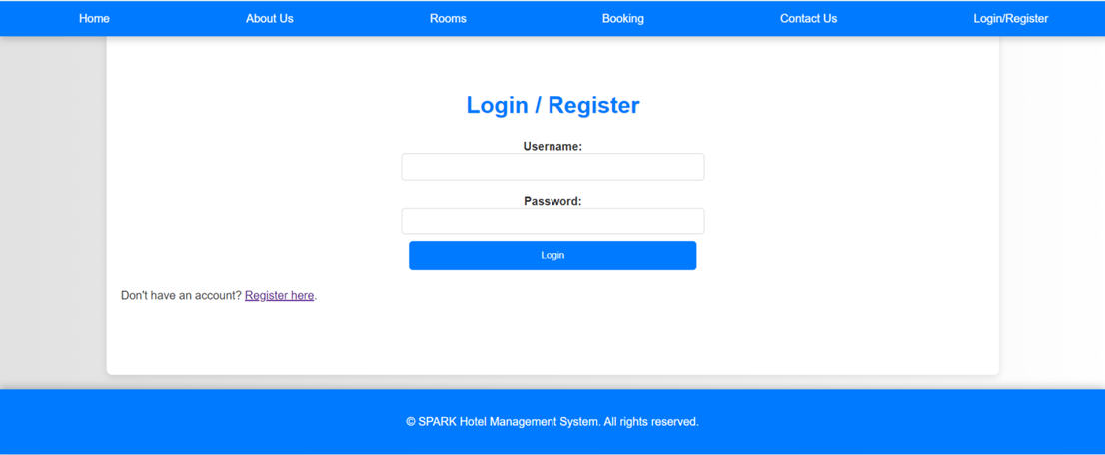

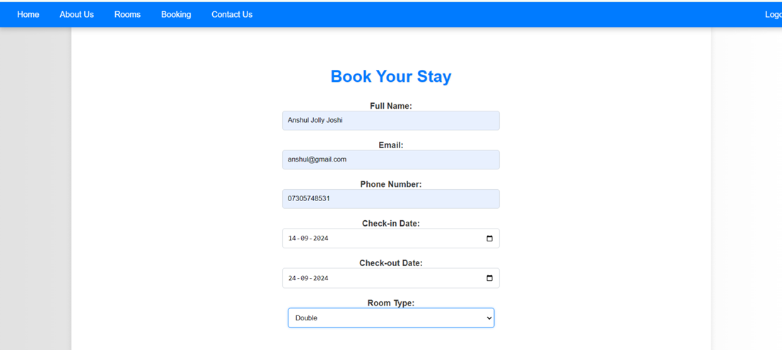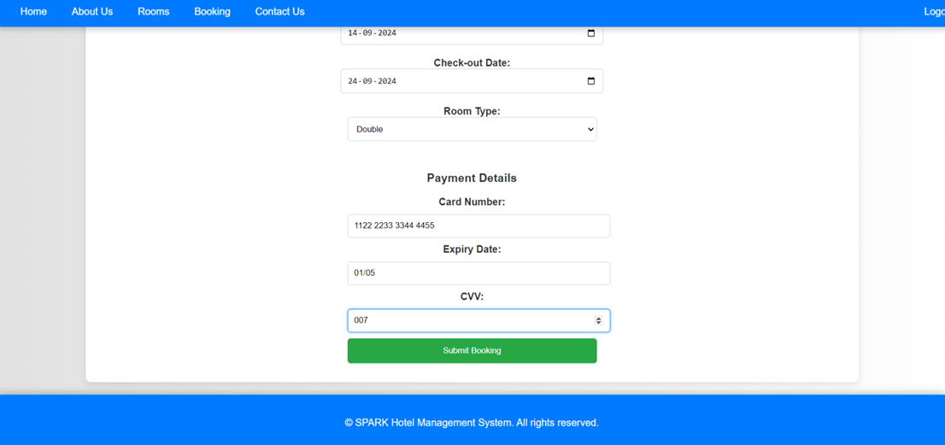

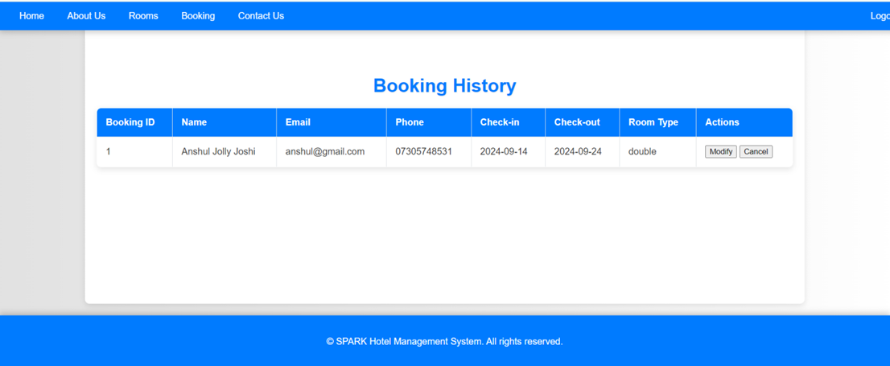The final output is a fully functional web application that allows users to register, log in, and view detailed information about the hotel. The system provides immediate feedback on successful registration and login attempts, ensuring users are informed about the status of their actions in real time. It accurately stores and manages user data in the database, ensuring the integrity and security of the information. The application is designed with an intuitive and easy-to-navigate user interface, making it accessible for users of all skill levels. Users can effortlessly browse through the hotel's services, check room availability, and make bookings. Additionally, the system allows hotel staff to efficiently manage bookings, track reservations, and generate necessary reports. By automating these critical processes, the system not only improves operational efficiency but also enhances the overall guest experience. This comprehensive approach ensures that both guests and hotel staff can rely on the system for smooth and effective hotel management. The integration of advanced web technologies such as HTML, CSS, JavaScript, PHP, and MySQL demonstrates the potential of these tools in creating a robust and user-friendly application that meets the dynamic needs of the hospitality industry.

**CONCLUSION**

The Online Hotel Room Booking project successfully automates the process of managing hotel bookings and user data, offering a streamlined and efficient solution for the hospitality industry. By leveraging a combination of advanced web technologies, the system significantly improves operational efficiency, reduces the likelihood of errors, and enhances the overall guest experience. The automation of these processes means that hotel staff can dedicate more time to providing high-quality service to guests rather than dealing with tedious administrative tasks. This project demonstrates the effective use of HTML, CSS, JavaScript, PHP, and MySQL in developing a comprehensive, user-friendly web-based application.

HTML (HyperText Markup Language) forms the backbone of the system, creating the structure and layout of the web pages. CSS (Cascading Style Sheets) is utilized to style these pages, ensuring they are visually appealing and responsive across various devices. JavaScript adds interactivity and dynamic content to the application, enhancing the user experience by allowing real-time updates and client-side validation. This ensures that data entered by users is immediately checked for errors, providing instant feedback and reducing the burden on server-side processing.

In summary, the Hotel Management System project is a testament to the power of modern web technologies in solving real-world problems. By automating the management of hotel bookings and user data, the system not only improves efficiency and reduces errors but also significantly enhances the overall guest experience. The effective use of HTML, CSS, JavaScript, PHP in this project highlights the potential of these technologies to create comprehensive, reliable, and user-friendly web applications that meet the needs of the hospitality industry.

**REFERENCES**

Hu, P. and Gu, D.X., 2013. Development and implementation of web-based online hotel reservation system. *Applied Mechanics and Materials*, *347*, pp.2947-2951.

Saito, T., Takahashi, A., Koide, N. and Ichifuji, Y., 2019. Application of online booking data to hotel revenue management. *International Journal of Information Management*, *46*, pp.37-53.

Moindjie, H., Camara, K. and Taqi, G.M., 2022. *Online Booking System* (Doctoral dissertation, Department of Computer Science and Engineering (CSE), Islamic University of Technology (IUT), Board Bazar, Gazipur-1704, Bangladesh).

Faliha, N., Siti, A.E., Kusdi, R. and Andriani, K., 2021. Online reservation system and online customer review: Its impact on brand image, trust and hotel booking decision. *International Journal of Economics, Business and Accounting Research (IJEBAR)*, *5*(4).

Cezar, A. and Ögüt, H., 2016. Analyzing conversion rates in online hotel booking: The role of customer reviews, recommendations and rank order in search listings. *International Journal of Contemporary Hospitality Management*, *28*(2), pp.286-304.

Sayyed, R., Patharkar, O., Tarade, A., Temkar, K. and Ashok, J.S., 2020. Online Hotel Management System. *International Journal of Research in Engineering, Science and Management*, *3*(7), pp.324-326.

Buga, H.O. and Ahabwe, B., 2012. *Developing a secure online booking system for the Slumber Land Hotel (Arua)* (Doctoral dissertation, School of Computing and Information Technology).

Nyondo, G., 2011. Online hotel management system.

Bhagat, A., Kaushal, S., Anand, A. and Mary, S.P., 2023, October. Decentralized Hotel Rooms Booking System Using Pragama Solidity and Blockchain Technology. In *Proceedings of the 6th International Conference on Intelligent Computing (ICIC-6 2023)* (Vol. 107, p. 119). Springer Nature.

Nyondo, G., 2011. Online hotel management system: a case study Rranova Hotel.